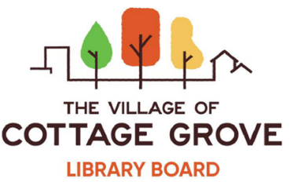
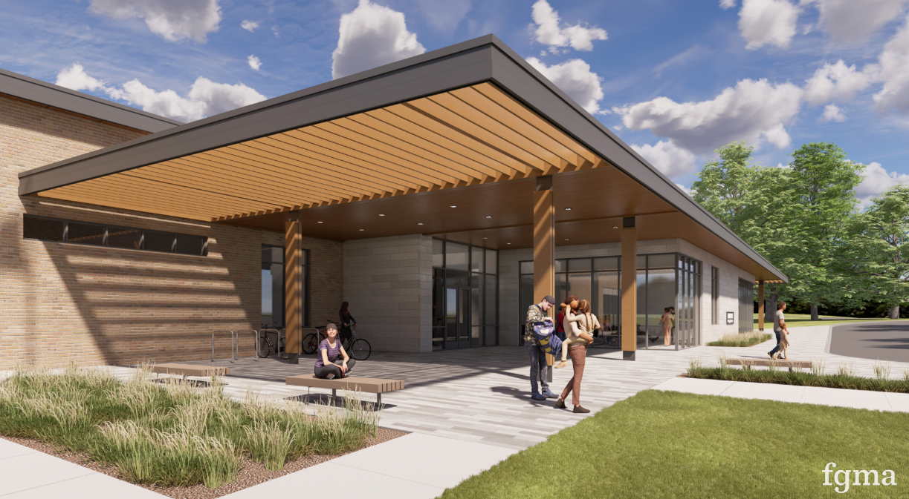
cindi Kelm- Nelson (President/Village Trustee)
JP Villavicencio (Vice President)
Erik Braun (Secretary)
Alison Anger (Treasurer)
Lisa Sutter (MG School Rep)
Meaghan Swanson
Jennifer Rose
Lucas Franklin, Facilities SubCommittee
Karl Schweitz, Facilities SubCommittee

Stephanie Rossing, Former Library Board Member
Stefan Wahe, Former Library Board Member
David Peterson, Former Library Board Member

Village Staff: Tracy Phillippi, Library Programming and Outreach specialist

Village of Cottage Grove Library Board
3-year Strategic Plan
2025-2028

Table of Contents
Executive Summary 2
Approach 3
Mission Statement 4
Vision Statement 4
Core Values 5
DEIA-BC Statement 6
SWOT Overview 7
Library Board SWOT 8
Facilities Subcommittee SWOT 9
Analysis Themes 10
SMART Goals 12
Detailed Actions and Timeline 13
1. Investigate and Acquire Physical Space (Facilities Subcommittee) 13
2. Formalize Staffing and Establish Library Department 13
3. Enhance Budget and Funding Efforts 14
4. Programming Strengthen Partnerships and Community Collaboration 14
5. Improve Marketing and Communications 15
Evaluation and Communication Plan 16
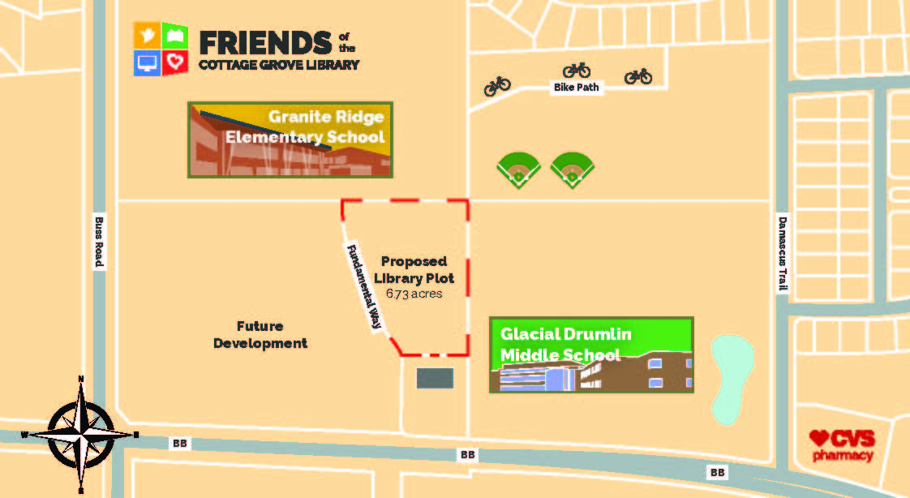
https://libraryfriendscgwi.org/
Friends of the Cottage Grove Library, Inc. Executive Committee
Robin Smekal, President
Nancy Engle, Secretary
Tom Olson, Treasurer

Executive Summary
The Library Board’s research since 2019 has shown that most Village of Cottage Grove residents strongly support libraries, library services, programs, and resources. Library infrastructure advances communities, providing technology access, literacy skills, and support for businesses, job seekers, and entrepreneurs. As positive indicators of municipal economic health and centers for community betterment, their safe, inclusive, and equal learning spaces are integral in today’s social, political, and economic climate.

Despite strong community support and the significant benefits of a physical library location, multiple obstacles related to the Village’s financial constraints and governmental procedures must be addressed. As the Library Board, we prioritize the development of a local public library as a key component of the Village's future public service plan, reflecting our commitment to enhancing community resources and services.

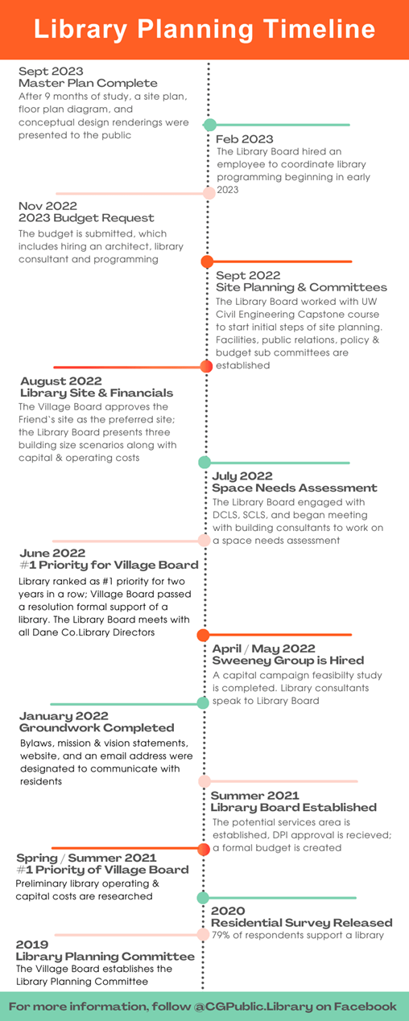
To achieve this goal, we have employed a formal strategic planning methodology. The following document outlines our approach and the specific steps we will take to establish clear objectives and goals for the period from 2025 to 2027, to be updated annually.

Top 5 Key Goals for the Village of Cottage Grove Library Board:
- Formalize Staffing and Establish a Library Department: Building a team and formalizing the organizational structure are critical for operational success. This includes defining roles and responsibilities and setting up administrative frameworks.

- Investigate and Acquire Physical Space: Identifying and securing a suitable location for the library is our foremost priority. This involves detailed location assessments, and planning to ensure the space meets some of the community needs as well as future growth.

- Enhance Budget and Funding Efforts: Securing financial resources through various channels such as grants, donations, and municipal funding is essential. We aim to create a sustainable financial plan that supports ongoing operations.

- Strengthen Partnerships and Community Collaboration (Programming, Service, and Overall Vision): Engaging with local organizations, schools, businesses, and community groups will enhance the library's integration into the community. These partnerships will provide additional resources, programming opportunities, and support for the library’s mission.

- Improve Marketing and Communications: Raising awareness and promoting the library’s services and benefits through effective marketing strategies is vital. This includes leveraging social media, community events, and other communication channels to reach and engage with residents. As well as a plan to disseminate information and priorities to the Village Board.

We believe that this strategic plan underscores our dedication to developing a library that will serve as a central pillar of community enrichment and development in the Village of Cottage Grove.

Approach
Strategic planning involves a structured approach to define direction, priorities, and resource allocation for achieving its long-term goals. Strategic planning is an ongoing process, not a one-time event. Thus, it requires dedication, flexibility, and adaptability to navigate changes and uncertainties, especially in the municipal government environment. Further, collaboration and commitment from all organizational levels and stakeholders are essential for successful implementation. As accomplished in the past several years of work, the Library Board has already established the Need for a public library, demonstrated the Want from residents, and taken the first steps in identifying the Commitment from individuals and potential donors. Knowing that we have refocused our objectives (reference July 2023 memo), strategic planning was the necessary next step. Outlined below are the steps the Library Board undertook throughout 2024:

- Defined Vision, Mission, and Values: Articulated the Library Board’s vision (long-term goal), mission (purpose), and values (core principles guiding actions). These statements served as the foundation for strategic planning.

- Conducted a SWOT Analysis: Evaluated our strengths, weaknesses, opportunities, and threats (SWOT analysis) to identify internal capabilities and external factors or variables affecting the Library Board, funding, and the building of a physical library.

- Set Clear Objectives and Goals: Defined specific, measurable, achievable, relevant, and time-bound (SMART) goals aligned with the Library Board’s mission.

- Developed Strategies and Action Plans: Based on our goals, the Library Board created strategies and deliverables outlining how the Library Board will achieve its objectives and break these strategies into actionable steps over the next three years.

- Implement and Monitor: The Library Board will monitor progress regularly, track key performance indicators, and make necessary adjustments to stay on course or adapt goals.

- Review, Adapt, and Communicate: Defined periodic reviews to assess the effectiveness of the strategies and a communication plan.

- Continual Improvement: Strategic planning is an iterative process. The Library Board will encourage a culture of continual improvement by learning from successes, challenges, and feedback, and incorporate these learnings into future planning cycles.

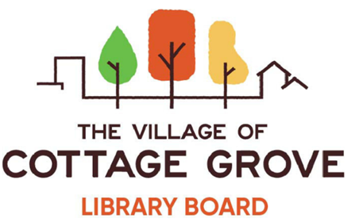

Mission Statement
The mission of the Village of Cottage Grove’s Library Board is to demonstrate a commitment to building a local public Library and providing its services as a core component of the Village’s public service plan. The Library Board represents the public in its stewardship and decisions for the library and the greater community it will serve. Our immediate goals include offering high quality programming that emphasizes diversity, equity, and inclusion and work to reduce information inequity, reviewing interim service and space needs, obtaining the required funds for the library, finding ways to work with the community and connect with public groups, and making sure that the needs and interests of the community are at the forefront of decision making.

Vision Statement
Our vision is to develop a long-term strategic plan to build a public library for our local community. A library is more than a building, it is a central component of our future community services. Libraries provide powerful resources for residents, businesses, and visitors alike. It is a place to meet and be informed, feel included, create opportunities, and support literacy and education.
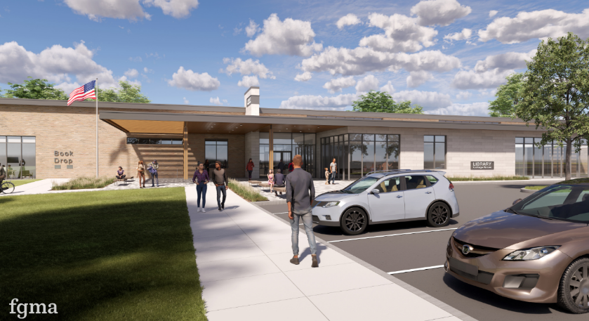
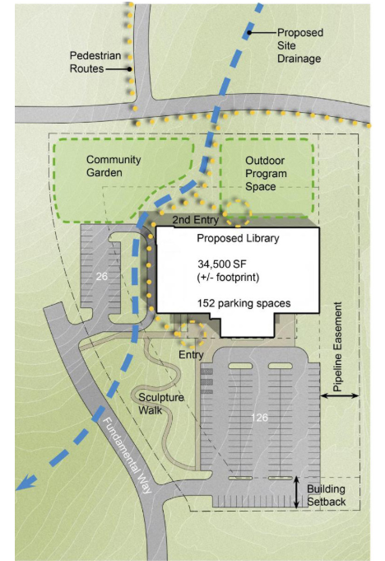
The 2023 FGM Architect Master Plan Recommended Site Layout Option. The recommended layout was created using feedback from the preliminary conceptual site layout options, data obtained by the Library Board, and community feedback.

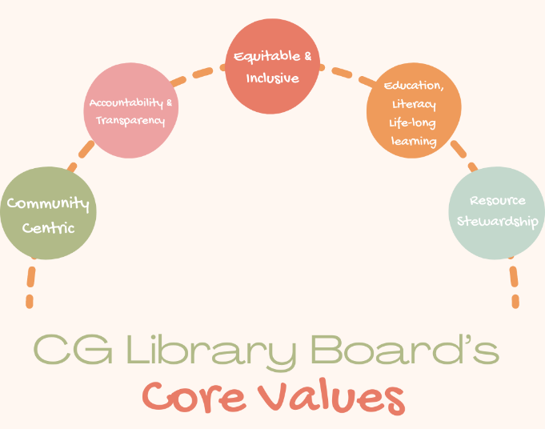
Core Values
Library Boards are responsible for the planning and programming of libraries. Thus, helping to establish core values that guide the current provision of services and resources to the community and the future planning of a library is necessary. Our core values reflect a commitment to serving the community, promoting knowledge, and fostering a welcoming environment as well as the broader principles of librarianship and engagement.
- Community-Centric
- Collaborate with community organizations, schools, and local businesses to enhance library services and programs in Cottage Grove and support shared goals.
- Prioritize the needs and interests of the local community when developing collections, programs, and services.
- Actively engage with community members to understand their preferences and address their needs.
- Regularly assess and respond to the changing needs of the community through community input, surveys, and feedback.
- Create spaces that showcase and celebrate the artistic and cultural diversity of the community.

- Accountability & Transparency
- Foster transparency in library operations and decision-making processes.
- Maintain open communication with the community, Village Board, and Village Staff and be transparent about decision-making processes.
- Operate with integrity, professionalism, and a commitment to serving the public interest.
- Be accountable to the community by regularly assessing and reporting on the library's impact and effectiveness.
- Stay adaptable and open to new ideas, encouraging creativity and experimentation.

- Equitable Access & Inclusivity
- Ensure that library services, resources, and programs are accessible to all members of the community, regardless of age, background, or socioeconomic status.
- Create an environment that welcomes diversity and fosters a sense of belonging for all community members.
- Embrace diversity in all its forms and create inclusive spaces where everyone feels welcome.
- Celebrate and promote cultural diversity through collections, programs, and partnerships that reflect the community's richness.

- Education, Literacy, & Lifelong Learning
- Support the development of information literacy skills and a commitment to lifelong learning among Cottage Grove residents.
- Provide resources and programs and accurate information that support formal and informal education, including literacy initiatives.
- Encourage residents to critically evaluate information sources and make informed decisions.

- Resource Stewardship
- Prioritize responsible and transparent financial management.
- Embrace and leverage appropriate tools and technology.
- Cultivate strong relationships with donors, acknowledge the contributions of donors, and communicate the impact of donations effectively.
- Strive to increase operational efficiency and continuously identify and implement process improvements.

DEIA-BC Statement
The Village of Cottage Grove Library Board is committed to fostering Diversity, Equity, Inclusion, Accessibility, and Belonging in Community (DEIA-BC) in all aspects of our work. We believe that libraries and their services are not just places for the community but are co-created with the community. We believe that library programs are essential services that should reflect the rich diversity of our community and our experiences, cultures, and backgrounds and we strive to ensure equal access to resources, knowledge, and opportunities for all. We provide a public service where everyone in our community feels valued, respected, and empowered. Together, we can create an environment that serves as a catalyst for positive change, learning, and understanding, regardless of who you are or where you come from.

- Diversity: We celebrate the diverse backgrounds, cultures, experiences, and perspectives of our community members. Our library programming will actively seek to represent and engage with different voices, traditions, and ideas. We provide a platform for underrepresented and marginalized communities, both in our programming and as a resource for learning and sharing their stories.

- Equity: We are committed to providing equitable access to library programs, services, and resources for everyone, regardless of their race, ethnicity, gender identity and expression, sexual orientation, age, ability, socioeconomic status, or other identity factors. We will continuously work to identify and remove barriers that may prevent individuals from participating fully in our programs.

- Inclusion: We aim to create an inclusive and welcoming environment in all our library programming. Our events and services will be designed to be accessible, respectful, and safe for all participants. We actively encourage the exchange of ideas and open dialogue, promoting a sense of belonging and shared community.

- Accessibility: Accessibility for library programming involves creating inclusive and welcoming spaces, where all community members, regardless of their abilities or limitations, can participate and benefit from the services and events offered. We should consider factors like physical accessibility (e.g., ramps and elevators in our spaces), providing alternative formats for materials (e-books, large print, or audiobooks, braille), and offering assistive technologies to ensure that patrons with disabilities can fully engage with library programming. In addition to physical accommodations, promoting accessibility in library programming also means prioritizing diverse and inclusive content, ensuring that events are well-publicized and open to all, and training staff to be knowledgeable and supportive in serving patrons with different needs.

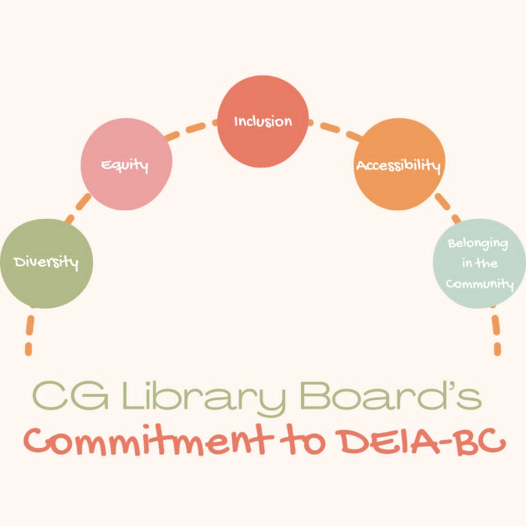
- Belonging in Community: All are welcome at library events in Cottage Grove. Our own internal implicit or unconscious bias affects how we interact with our neighbors and shape our culture. Thus, acknowledging unconscious bias in decision making is the first step toward fostering equality in our choices. We value the input and contributions of our community members in shaping our library programs and services. Ideas, feedback, and expertise help us co-create a library that truly serves your needs. We will actively seek community input, engage in partnerships, and offer resources and support to community members who wish to actively participate in library programming.

SWOT Overview
The purpose of the SWOT¹ (Strengths, Weaknesses, Opportunities, Threats) analysis for the Cottage Grove Library Board was to inform and guide our strategic planning process. As we strive to enhance our services and community impact as well as look for interimpermanent library space, this analysis will provide insight into our current standing and prospects. Through a collaborative discussion, we aimed to identify key areas of improvement and capitalize on emerging opportunities to better serve the community.

Strengths:
- What do we do better than anyone else?
- What unique resources do we have?
- What positive aspects do our residents mentioned most often?
- What are the current strengths of our village facilities/locations in terms of location, size, layout, and amenities?
- How well do our village facilities meet the needs of our attendees?
- Are there any unique features or resources in our village facilities that give us an advantage?
- How effectively are our village facilities currently utilized?

Weaknesses:
- What resources or capabilities do we lack?
- What areas need improvement to achieve our goals?
- What do other libraries do better than us?
- Where have we received criticism or complaints?
- Are there any internal processes that are inefficient or hindering our progress?
- What are the limitations or shortcomings of our current village facilities in terms of space, functionality, or condition?
- Are there any areas within our village facilities that are underutilized or inefficiently used?
- Do we have any safety or accessibility issues that need to be addressed?
- Are there any regulatory or compliance issues related to our facilities?

Opportunities:
- What trends or changes in the Village could benefit us?
- Are there any upcoming events or developments that we can leverage?
- Are there any untapped markets we could target?
- What opportunities exist to expand or improve our current facilities to better meet our needs?
- Are there any new technologies or trends in facility management that we could leverage?
- Are there any potential partnerships or collaborations that could enhance our facilities?
- Are there any changes in our industry or market that could create opportunities for our facilities?

Threats:
- What obstacles do we face in achieving our goals?
- Are there any economic, political, or regulatory factors that could impact us negatively?
- What external factors could negatively impact our facilities?
- Are there any potential risks related to our facilities?
- How might changes in workforce preferences or remote work trends impact our facilities?

On February 21, 2024, the Library Board Facilities Subcommittee met in session and completed a SWOT analysis. The Library Board also completed a SWOT analysis during the March 19, 2024, meeting. Refer to posted agendas, meeting minutes, and recorded videos for further details.

Library Board SWOT

Strengths:
CG library usage is increasing annual
Receptive in the community
Diversity in programming/age groups
Friends of CG, resource: partnerships
Partners with businesses
In kind donations
Underdog
Outreach coordination
Schools
Monona/McFarland
Loyal following
Donors
Welcoming
Receptive to feedback
Execute ideas and strategies
Expertise
DEI lens: accessibility, language barriers
Recognition: from our library peers
Budget/donation
Work with all village departments
Costs isn’t a barrier to attending
Efficiency: increase value of the tax dollar
Creative-no limitation
Collaboration
Community volunteers
Bookmobile
Passion
Helpful
Maintain of land
Full master plan
Professional grant writing

Weaknesses:
Lack central space: informal programming can’t happen
No storage space
Staff isn’t full time
Don’t have a library director
Not having SCLS membership
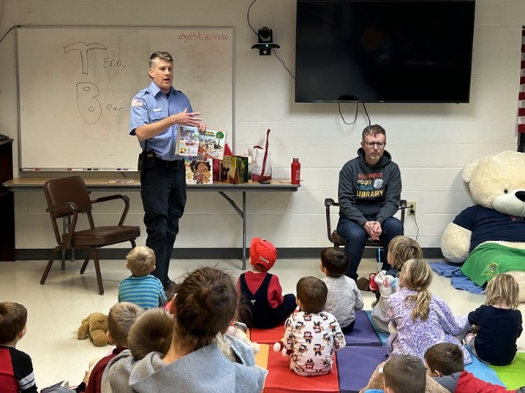
Library card access
Bookmobile: access and location, times
Study rooms/teens/resources lacking
No collection
No book return
Small budget
Space planning with parks
Lack inside location
Department status
Interim space won’t meet full needs
Communication strategy
Lack of inter-library loan options

Opportunities:
Short-term space-provides identity
Centennial showcase
DCLS/SCLS
Generate revenue/capital campaign
New marketing strategies
Cultivate relationships

Threats:
Bookmobile being out of service for months
Levy limits
Dissolved
Support from VB
Support from committee
Weather
Parks space
Loss of reduction of support from community
FMP-not slated for a year
Referendums that aren’t library (increasing taxes)
Prioritization processes
HeyDay development, land impact
Confusion with space
Misinformation
Volunteer model
Historical perception
Burnout

Facilities Subcommittee SWOT

Goal: The subcommittee had a more defined goal of identify opportunities to identify and acquire space for library programming (and possible small collections and book exchanges):

- Strengths: What are the strengths of the library board and community in acquiring physical space for library programming?
- Weaknesses: What are the limits to the Library Board in achieving the goal?
- Opportunities: What are the opportunities for achieving the goal?
- Threats: What are the external factors that can limit success?

Strengths:
Tangible
Master plan exists
Huge step up from the Bookmobile
Robust programming
We have the people
Passion
Friends of the Library have existed since mid-1990s
Central location

Weaknesses:
No current space has been identified
Wouldn’t fit needs of community for the long term
We use multiple (21) programming spaces
No library
Lack a collection
Volunteer driven-not sustainable
Accessibility (ADA, walkability, transportation)
People don’t know what they don’t have
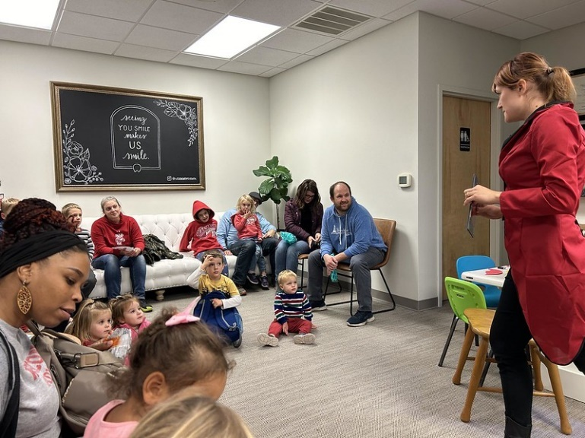

Opportunities:
Space gives motive for funding
Can cultivate our own (small collection)
Membership to SCLS-new service and support
Free access to internet, space, meeting space; print copy fax
Central location for space
Rent-commercial space
Time to make a strong case for space, and why its needed now
Amazon
Generate revenue (i.e. book sales)
Permanent book drop off
Storage
After school options/no school days
Workspaces
Collaborations with business community (establish small business Saturday year-round)
Space for Historical
Fill programming gaps
Support marginalized communities

Threats:
Renting long-term
Not eligible for DCLS tax reimbursement
Potential moves
Staff/hours
Budget
Village Board/Staff support
Lack of Village facilities strategy
Operational budget
Collection: live load
Lack of library director
Historical perception

Analysis Themes
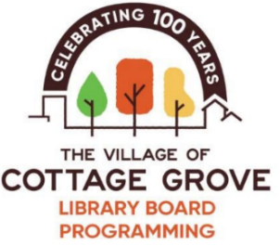
Here, we combine the themes and ideas collected from the two discussions to identify the Library Board goals and objectives. The Facilities Subcommittee analysis was specific to identifying and acquiring space for library programming (and possible small collections and/or book exchanges). The Library Board’s effort was broad, addressing potential areas of improvement and how to capitalize on emerging opportunities that will better serve the Cottage Grove community.

The following are themes that emerged from both discussions:

The results of the two discussions resulted in the following strengths.
- Library Programming: Library programming has been consistent and well-attended for the past year. The programming offered has supported community efforts and included themes that support the diversity of our growing community and society. Local businesses and organizations have supported library programming by providing space and supplies, including many in-kind donations. The Library Programming and Outreach Specialist has demonstrated a strong acumen for planning, organizing, and facilitating programs, while volunteers have also shown a willingness to support these efforts. Library Programming has demonstrated some additional services a community library can provide. The continuation of funding for the second budget year demonstrates ongoing support and need for this service. As the Village population continues to grow, there may be more of a need for these programs.

- Staffing and Volunteers: Our part time staff person has delivered a full program while being limited to a part-time position (now 20 hours a week). She has been able to partner with libraries for support and services and has successfully acquired the services of content providers (vendors) and volunteers to provide program offerings. This has been successful on a very limited budget.

- Grant Funding/Foundation Support: The Board has demonstrated success in submitting grant requests to support library programming. This funding augments a limited budget, providing a higher quality of programming.

- Partnerships: The Board has acquired a more robust understanding of needs, opportunities, and programming through partnerships that include, but are not limited to, Monona Grove school librarians, community librarians, other Village departments, the Chamber of Commerce, and the Friends of the Cottage Grove Library, Inc. Through collaboration with the library architects, the Board has a better understanding of facility needs, features, and costs. A financial feasibility study has demonstrated the ability to raise funding for the capital project. Dane County, South Central and area libraries have been used as information-seeking resources. As the Village continues to grow, additional partnerships may become more efficient.

- Communications and Marketing: Communication and marketing have successfully reduced misinformation about library planning and promoted programming events. Attendance and FB metrics are increasing. The creation of a FAQ was intended to reduce misinformation.

Based on the discussion, the following risks can impact the sustainability of library programming and the provision of the community with a full suite of library services.
- Physical Space: The need for dedicated physical spaces significantly impacts the Cottage Grove Library's identity. Without space for a collection, residents do not have the opportunity to check and return materials on time and we don’t have space in Cottage Grove for the other needs of a library. Reliance on the Bookmobile has demonstrated intermittent impacts on service delivery due to mechanical issues. The lack of physical space limits participation in the South-Central Library System. There needs to be a consistent space to provide after-school/no-school-day programming. The lack of physical space also impacts the potential generation of additional revenue (e.g. DC library tax).

- Budget and Funding: A limited budget impacts service offerings by limiting vendors/service providers' options and programming quality and could deter future staff hiring. Additionally, there are limitations for access to resources (DC, SCLS, interlibrary loan, collection services).

- Staffing: The loss of current staffing will disrupt the delivery of library programming and result in a loss of institutional knowledge. Current staff limited hours (below market rate salary) put a cap at the level of the service to the community. Volunteer-driven support is not sustainable for the delivery of consistent and quality programs. Lack of a hired Library Director moves much of the responsibility to the Library Board president.

The following are potential opportunities to consider when setting Library Board goals.
- Physical Space: Investigate the costs and needs of short-term physical space needs. What are the minimum spaces to start. What could an initial membership with SCLS help with; and how might the changes in 2025 to Dane County standards impact us. An anchored space, not mobile, that brings people together. Focus on the next 5 years.

- Library Program Coordination: Establish the Cottage Grove Library as an official Village department and formalize future staffing needs. Determine how the staff is integrated with other village departments and how a job title, and responsibilities/duties will change over time. The library general fund needs to increase.

- Centennial Showcase: Identify how the Library Board and Library Programs can participate in the CG Centennial Showcase as a short-term goal to improve outreach.

- Funding and Fundraising: Performa a revision to the budget annually, work into the FMP. Identify opportunities for specific fundraising and grants for short-term space programing and materials.

- Marketing and Communications: Identify other methods for communicating program opportunities and educational services beyond social media platforms.

SMART Goals

2023-2024 Programming Mission/Vision Statement
to offer meaningful library experiences to residents and visitors of all ages, abilities, and backgrounds. The mission of the Library Board’s Programming efforts is to carefully plan and execute programs and events and ensure high engagement, participation, and opportunities for the Cottage Grove community The Village of Cottage Grove Library Board is committed to fostering Diversity, Equity, Inclusion, Accessibility, and Belonging in Community in our work. This directly expands upon the Library Board’s vision to provide no-cost, high-quality resources for residents, businesses, and visitors in order to create opportunity and support literacy and education.

These SMART (Specific, Measurable, Achievable, Relevant, Time-bound) goals address the critical areas of space, staffing, funding, partnerships, and communication:

1. Formalize Staffing and Establish Library Department
Specific: Establish the Cottage Grove Library as an official Village department and transition the Library Specialist to a full-time position. Determine title, roles and responsibilities changes, revise job description.
Measurable: Complete the official establishment of the library department and transition staffing within the set timeframe.
Achievable: Collaborate with Village staff and secure necessary approvals and funding.
Relevant: Ensures sustainable growth of library programming and operations.
Time-bound: Achieve the official establishment and staffing transition within a year (September 2025).

2. Investigate and Acquire Physical Space(s)
Specific: Identify and secure a dedicated physical space for the Cottage Grove Library to facilitate programming and anchor the library.
Measurable: Complete a feasibility study for short-term space solutions, budget, and identify at least one physical location.
Achievable: Work with the Facilities Subcommittee, realtor, DC, SCLS, Village Staff and Board to identify available spaces and funding.
Relevant: This addresses the critical need for a physical library space to enhance services and community identity.
Time-bound: Complete information gathering and estimated budget and secure a physical location for 2026.

3. Enhance Budget and Funding Efforts
Specific: Secure additional funding through grants and other financial resources to support high-quality programming and operations.
Measurable: Increase the library’s programming budget by 25% within the next fiscal year (2025).
Achievable: Identify and apply for at least 2 new grants and explore alternative funding options (create database).
Relevant: Provides sustainable funding to support staff, services, and programming expansion.
Time-bound: Achieve the budget increase and secure new funding sources (Fall 2024).

4. Strengthen Partnerships and Community Collaboration (Programming, Service, and Overall Vision)
Specific: Develop and maintain partnerships with local schools, community organizations, businesses, Friends of the Library, and other key stakeholders.
Measurable: Establish at least five new partnerships and conduct biannual meetings with existing partners.
Achievable: Leverage current relationships and actively seek new collaborative opportunities.
Relevant: Enhances programming, facilities, and community engagement through partnerships.
Time-bound: Establish new partnerships and hold meetings starting within three months and ongoing thereafter.

5. Improve Marketing and Communications
Specific: Develop and implement more comprehensive marketing and communication strategies to promote library programming and reduce misinformation surrounding the overall project.
Measurable: Increase program attendance.
Achievable: Use multiple communication channels, including community bulletins, local newspapers, and partnerships with organizations. Biannual presentations to Parks committee, annual report to Village Board. Create a formal strategy and budget.
Relevant: Ensures effective promotion of library services and community engagement.
Time-bound: Implement new communication strategies within 2 years.

Detailed Actions and Timeline
*This document will be reviewed and updated regularly to reflect changing circumstances and priorities.
**For transparency, red text indicates potential budget items.
***Underlined text corresponds to SMART Goals.

1. Formalize Staffing and Establish Library Department
Year 1, 2025 | Year 2, 2026 | Year 3, 2027
- Implement a performance and personnel measurement system to track progress.
- Regularly report progress to the Library Board, Village Board, and community stakeholders.
Create a formal department organizational structure.  - Develop a detailed organizational chart. | Work with the Library Board to structure department to align with Mission, Vision, and Core Values. | Conduct a workload analysis to determine the need for additional part-time staff.  - Needs assessment for a part-time staff.  - Establish a timeline for recruitment and hiring.
Increase ‘Library Outreach and Programming Specialist’ to full time for 2026. | Implement a professional development plan.  - Determine professional training needs (workshops and conferences) that align with goals of the department. | Develop a budget proposal for hiring part-time staff.
Work with HR to revise roles and responsibilities.  - Define clear job descriptions for each role. | Conduct a volunteer needs assessment.  - Create volunteer position descriptions and responsibilities.  - Develop a volunteer recruitment and training plan. | Initiate diversity and inclusion policies within the staff and programs.  - Develop a communication plan to inform the community about changes.
Develop new programming and service initiatives.  - Programming/Service budget increases by 25% annually. | Develop new programming and service initiatives.  - Programming/Service budget increases by 25% annually. | Develop new programming and service initiatives.  - Programming/Service budget increases by 25% annually.

2. Investigate and Acquire Physical Space(s) (LB Facilities Subcommittee)
Year 0, 2024 | Year 1, 2025 | Year 2, 2026 | Year 3, 2027
- Regularly report progress to the Library Board, Village Board, and community stakeholders.
- Regularly update and consult with finance to stay within budget.
Determine short-term space(s) definition and list benefits to the greater community. | Determine costs per sq ft and secure options for rental space.  - Preliminary estimates for acquisition (and potential renovation costs). | Acquire location. | Assess the effectiveness of the acquired space and make necessary adjustments.
Define how space(s) will be used. | Present a capital and operational budget request for space and furnishings for the 2026 budget.  - Develop a proposal and timeline for acquisition and preparation of space.  - Track the progress of the feasibility study, space acquisition timelines. | Work with stakeholders to evaluate space function. | Revisit space needs.  Plan for future expansion or additional space needs.
Engage with stakeholders.  - Friends of the Cottage Grove Library, Realtor, DCLS, SLCS.  - Evaluate facilities committee structure and member expertise and increase meeting frequency. |  | Develop a communications plan for facilities. | Track the usage rates of the new space.
Explore new opportunities for funding.  - Work with the finance director to establish a budget-need list.  - Investigate grants  - Determine capital campaign needs and fundraising strategies.  - Work with the Friends and other community groups.  - Collect relevant information |  | Develop budget proposal. | Develop budget proposal.

3. Enhance Budget and Funding Efforts
Year 1, 2025 | Year 2, 2026 | Year 3, 2027
- Regularly report progress to the Library Board, Village Board, and community stakeholders.
- Regularly update during open meetings and consult with finance to stay within budget.
- Develop and implement a risk management plan to address potential financial shortfalls or funding challenges.
Identify capital budget needs and submit to be considered in the FMP. | Identify capital budget needs and submit to be considered in the FMP. | Identify capital budget needs and submit to be considered in the FMP.
Identify annual operational budget needs and submit to be considered in Village Budget. | Identify annual operational budget needs and submit to be considered in Village Budget. | Identify annual operational budget needs and submit to be considered in Village Budget.
Submit the full library master plan for consideration. | Submit the full library master plan for consideration. | Submit the full library master plan for consideration.
Apply for additional funding through various grant mechanisms. Establish a trust for supplementation of budget. | Apply for additional funding through various grant mechanisms. | Apply for additional funding through various grant mechanisms.
Monitor actual and budgeted funding categories. | Monitor actual and budgeted funding categories. | Monitor actual and budgeted funding categories.
Explore opportunities for funding.  - Work with the finance director to establish a budget-need list.  - Investigate grants and capital campaign needs. | Outline a more detailed strategy for identifying and applying for grants, including timelines, responsible parties, and specific grant opportunities. | Provide training or professional development opportunities for staff on grant writing and financial management.
Explore potential collaborations with other libraries, educational institutions, or community organizations for joint funding opportunities. | Work with stakeholders and subcommittees to identify budget and funding opportunities and risks. | Engage the community more directly in the funding process, perhaps through fundraising events, public meetings, or surveys.

4. Strengthen Partnerships and Community Collaborations (Programming, Service, and Overall Vision)
Year 1, 2025 | Year 2, 2026 | Year 3, 2027
- Create a feedback loop to ensure continuous improvement based on input from community members, staff, and partners.
Continue to work toward including DEIA-BC in our mission/vision, programming, and service.  - Develop a Land Acknowledgement Policy  - Include formal DEIA-BC training for staff. | Develop joint programs and initiatives with partners.  - Clearly define metrics for evaluating partnerships, community engagement, and programming success. | Increase social media and online presence to enhance community outreach.
Implement a formal criterion for determine programing, service, and partner success (grading scale, rubric). | Long-term partnerships.  - Evaluate the impact of partnerships on library services.  - Outline a strategy for developing and maintaining long-term partnerships beyond the initial three years, including how to sustain and grow these relationships. | Work with Village Staff to amend Library Specific Questions in the Village Community Survey.
Develop an annual Library Community Survey  - As needed, use suggestion box at programs and online forms to collect ongoing feedback. | Implement a formal performance measurement system to track progress. | Present updates at the Village Board, School Board, and Chamber of Commerce.
Compare programming and service with area libraries to assess relative performance and identify areas for improvement. | Conduct an annual library meeting with community members, staff, and partners to gather feedback on services and programming. | Work with external partners to increase services in Cottage Grove.
Identify and establish partnerships with local schools, businesses, and organizations. | Use findings to revise/adjust programming and service budgets. | Revise Stakeholder engagement documents.
Conduct an annual library meeting with community members, staff, and partners to gather feedback on services and programming. |  | Consider resource allocation within budget to meet this goal’s objective.

5. Improve Marketing and Communications
Year 1, 2025 | Year 2, 2026 | Year 3, 2027
- Present annually at a Village Board meeting.
- Track engagement levels on various communication platforms
- Work with Village staff to streamline and develop consistency regarding communications planning.
Develop a detailed community engagement plan.  - Consider the need for additional advisory groups (e.g., DEI, event planning committees)  - Integrate communications planning and dissemination across the goals of this strategic plan. | Develop an accessible communication plan:  - Ensure that all communications are accessible to people with disabilities, including the use of alt. text for images, captioning for videos, and offering materials in multiple languages as needed.  - Inclusive Representation: Ensure that marketing materials represent the diversity of the community and that all voices are included. | Ensure that all communications maintain consistent branding, including logos, colors, tone, and messaging across all platforms.
Create a dedicated section on the library’s website for strategic plan updates, including progress metrics and upcoming initiatives. | Develop a clear understanding of the target audiences (e.g., demographics, interests) and tailor communications strategies to effectively reach each group.  - Diversify communication channels. | Provide staff with training on effective communication strategies, including social media management, public speaking, and community engagement.  - Ensure that staff are trained in cultural competency to communicate effectively with diverse community groups.
Improve school district communication  - Work directly with MGSD partners | Develop a communications budget.
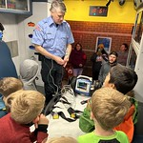
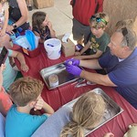
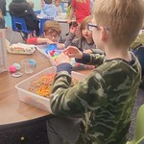
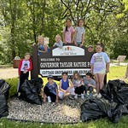
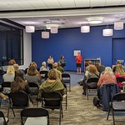
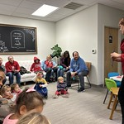
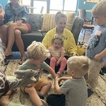
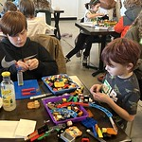
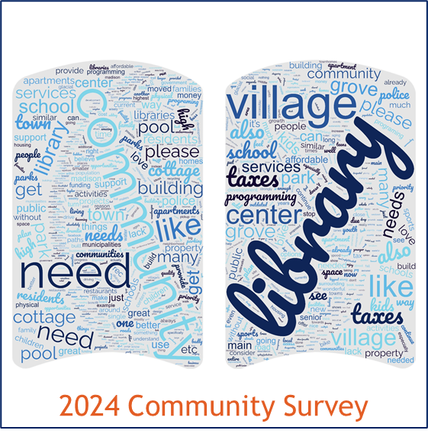
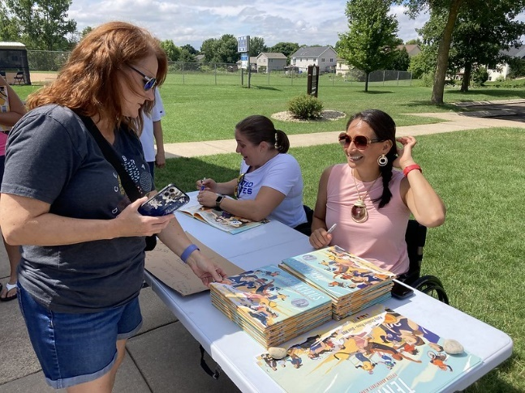
Evaluation and Communication Plan

Develop Key Performance Indicators:
- Create a spreadsheet to visualize KPIs and progress in real-time.
- Staffing and Departmentalization: Monitor the progress of establishing the library as a Village department, hiring full-time staff, and reducing volunteer dependency.
- Physical Space: Track the progress of the feasibility study, space acquisition timelines, and the usage rates of the new space.
- Funding: Measure the amount of new funding secured, number of grants applied for, and the budget increase percentage.
- Partnerships: Count the number of new partnerships formed, frequency of partnership meetings, and the outcomes of these collaborations.
- Marketing and Communications: Track program attendance rates, engagement levels on various communication platforms

- Conduct an in-depth annual review of the strategic plan to evaluate overall success and areas needing adjustment, especially considering the Villages financial landscape.
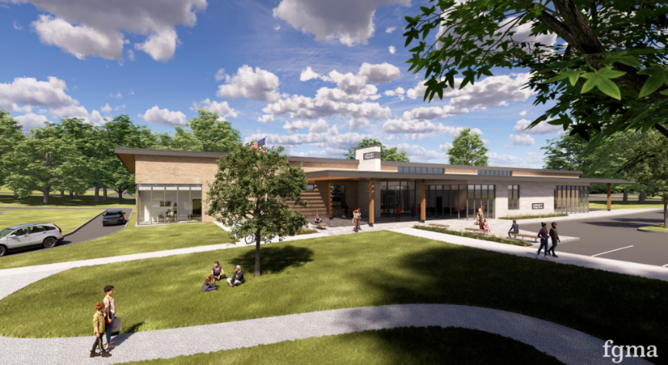
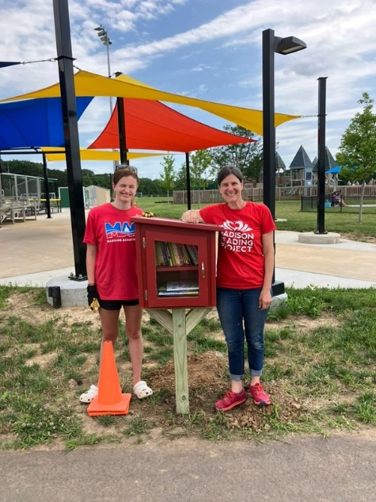
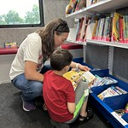
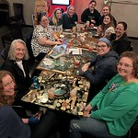

SWOT stands for Strengths, Weaknesses, Opportunities, and Threats. A SWOT analysis is a framework to help assess and understand the internal and external forces that may create opportunities or risks for an organization.

